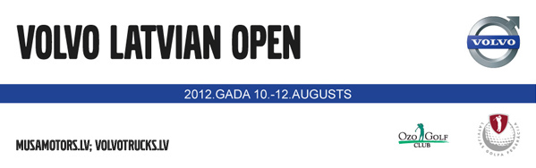

VOLVO Latvian Open
August 10-12, 2012

ENTRY FORM

I wish to enter the VOLVO Latvian Open competition and declare to being an Amateur golfer in accordance with the Rules of Amateur Status of the R&A or USGA.

Name: Mr. ◻ Mrs. ◻ Ms. ◻ _________________________________________

Address: _________________________________________________________

Phone: ____________________ E-mail: _____________________

Date of birth: _______________ Nationality: _____________________________

Home club (country): _____________________________________________

Handicap*: _________________________________________________________
(*not exceeding: men - 15, women - 20)

Date: ____________ Signature of competitor: _____________________

HCP and Amateur status are confirmed by:
National association/club: _____________________________________________

Date/Signature: ___________________________________________________

Tournament entry forms are to be sent by fax to the
Ozo Golf club: +371 67394034 or email ozogolf@apollo.lv
Closing date: August 6th

